Joint Optimal Service Chain Allocation, VNF instantiation and Metro Network Resource Management Demonstration

Author name(s) [10-point type, centered, bolded]
¹Universidad Politécnica de Cartagena, Cuartel de Antiguones, Plaza del Hospital 1, 30202 Cartagena, Spain
Email: javier.moreno@upct.es

Abstract: In the context of the Metro-Haul project, we demonstrate the interaction of ETSI Open-Source Mano Network Function Virtualization-Orchestrator and open-source Net2Plan planning tool to jointly optimize VNFs placement and the metropolitan optical transport network resources.
OCIS codes: (060.4250) Networks; (060.4256) Network Optimization.

1. Introduction
Metropolitan area networks play an essential role in telecom operators’ infrastructure to satisfy the near-future requirements of the 5G era. Among other key performance indicators, 5G networks are expected (i) to use a scalable management framework enabling fast deployment of novel applications, (ii) to reduce the network management OPEX by at least 20% compared to today and (iii) to ensure End-to-End latency below 1ms. Network control within software-defined networking (SDN) and virtual functionality provided by network function virtualization (NFV) can ease the achievement of 5G goals. Hardware disaggregation is one of the main features of SDN which translate into OPEX profits due to its more scalable management and multi-vendor interoperability. A service chain is the deployment of the sequence of several individual network functions (e.g. firewall, package analyzing) to yield a complex demand. The instantiation of virtual network functions (VNFs) in virtual machines (VMs) can improve the management of service chains and this is exactly what NFV is in charge of. A SDN-NFV framework can benefit by using jointly a planning tool, such as Net2Plan [2], providing an efficient Metro network resources management.
This work is contained within the H2020 Metro-Haul Project [2]. In the aforementioned context, the Metro-Haul proposes cost-effective, energy-efficient, agile and programmable metro networks that are scalable for 5G access and future requirements, encompassing the design of all-optical metro nodes (including full compute and storage capabilities), which interface effectively with both 5G access and multi-Tbit/s elastic core networks.
2. Overview
This demonstration showcases the interaction of a NFV-Orchestrator (NFV-O), in our case Open-Source MANO (OSM) [2], with Net2Plan, an optimization-algorithm-aware planning tool, to optimally deploy VNFs and manage the available Metro optical network resources in order to satisfy the 5G objectives. The Metro-Haul network proposal is a set of interconnected Metro edge and Metro Core nodes. Edge and regional data-centers (DCs) are attached to edge and core nodes respectively, both types of nodes are provided by storage and computational resources oriented to allocate NFV functionality. Storage and computational capacity are essential to build a SDN-NFV-based management framework enabling fast configuration time to set up or reconfigure services handling 5G applications, and this is where this work plays a main role.
The aim of the present demonstration is to provide a proof of the use of a specialized planning tool Net2Plan using NFV service-chain allocation algorithms to assist the NFV-O and T-SDN in the search of the optimal solution. An overview of the demonstration is shown in Fig. 1, a complete dissemination of the modules that compose this architecture is explained as follows: (i) OSS: operational support systems, represents an operator to deploy an application service (ii) the NFV-O module is represented by OSM which is in charge of the virtualization infrastructure, OSM manages and deploys Virtual Infrastructures Machines (VIMs), with some storage and computational capacity, where allocate the VNFs, (iii) the Netphony module is a BGP-LS Speaker, a Traffic Engineering Database and a Topology Module pointed to afford an overview of the emulated transport network. (iv) Net2Plan is a network planner tool in charge of, firstly, collecting the status of the virtualization platform (IT resources) coming from OSM and the network status (topology, bandwidth of the links…) from the Netphony module and the user’s demand request; secondly, provides an optimum solution to allocate IT and network resources in order to satisfy user’s demand, and finally send the results to OSM and the T-SDN (Netphony). To enable this operation, some interfaces have to be defined and used: (i) I-OSSNFVO: is the communication interface to exchange information between the operator and the OSM via ?, (ii) I-POSS: a REST-API-based interface between OSM and the planner tool, Net2Plan, (iii) I-PTSDM: interface Net2Plan-Netphony via REST-API.
In order to enhance the comprehension of this scenario, the procedure when the operator request to deploy a service will be as follows: (i) …

Considerar algunos algoritmos de Net2Plan que se puedan usar aquí.
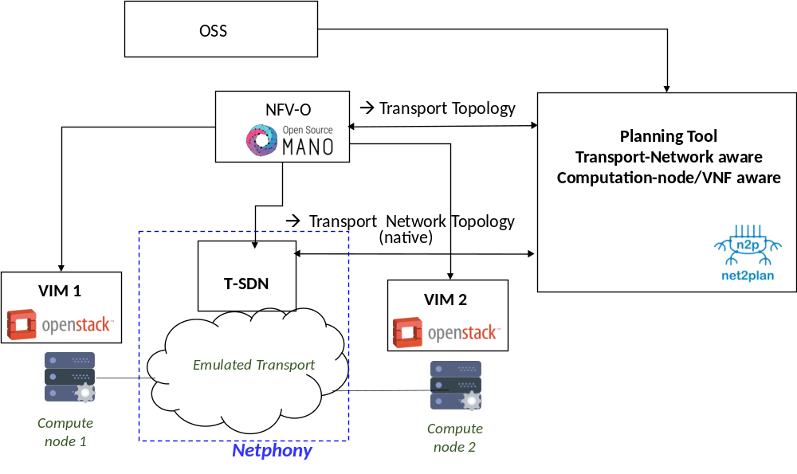
Fig. 1. Demonstration overview. NFV-O: Network Function Virtualization - Orchestrator. OSS: operational support systems VIM: Virtual infrastructure manager. Netphony: BGP-LS Speaker and Traffic Engineering Database
3. Innovation
Texto anterior.
Es OSM reciente? Hay otra gente que ya lo haya usado y/o definido interfaces para comunicarse con OSM?
Además, explicar que respecto a las demos del año pasado (que “solo” definían interfaces) nosotros estamos un paso adelante porque usamos algoritmos de optimización (open-source available).
4. OFC Relevance

Acknowledgments
This work has been performed in the framework of the H2020-ICT-2016-2 Metro-Haul project.
References
- P. Pavon-Marino et al., “Net2Plan: An Open Source Network Planning Tool for Bridging the Gap between Academia and Industry”, IEEE Networks, Sept. 2015.
- Metro-Haul Project. https://metro-haul.eu/
- Open Source Mano. [Online]. Avalilable: https://osm.etsi.org/
- Añadir algunas de las refs de demostraciones OFC 2017.

